**Unit Test Results for simple search**

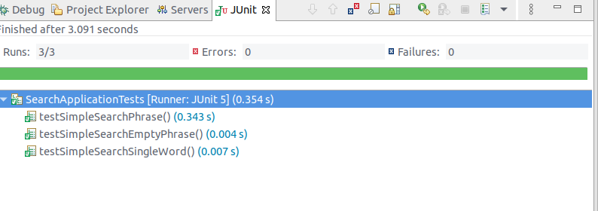

**Performance Test results for 3 methods.**

Total 1000 calls for 10 search terms.

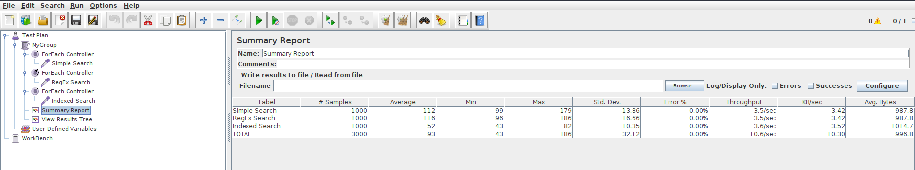

Search terms used for performance test:

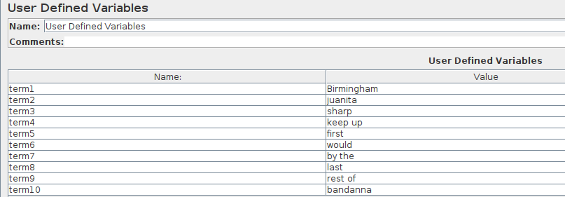

Test result for 100000 calls for each of the methods

